

**University Of Balamand**

**Faculty of Engineering**

**Advanced Electric Machines**

**Dynamic Analysis of Direct Current Machines**

Presented to: Dr. Maged B. Najjar

Presented by: Kifah DAHER  
 Martine CHLELA

Date: 17-12-2012

**Abstract:**

This project analyzes the dynamic behavior of a DC generator. The dynamic behavior of a cumulative short DC generator is studied and simulated using MATLAB. The selected generator is rated at 300 V, 30 kW, four poles. Different tasks are considered:

1. In task 1 the steady state characteristics (VT vs IL) are obtained. As well the Torque vs speed and analysis is done regarding those characteristics.
2. In task 2 the transient behaviors of the generator during a temporary change in the speed maintaining a constant load current.
3. The third task is to simulate the dynamic behavior of the machine when changing the load while maintaining a constant speed.
4. In the final task the generator is simulated to show the effect of the filed change by varying resistor values.

The system of differential equations is numerically solved using MATLAB.

The DC generator is a 300V Cumulatively Compounded type with short shunt connection having the following data:

Shunt field resistance rf = 130 Ohms

Series field resistance rfs = 0.14 Ohms

Armature resistance ra = 1.65 Ohms

Mutual inductance between shunt and series fields Lffs = 0.154 H

Lumped damping coefficient Bm = 0.25 N.m.s

Lumped Inertia J = 11 Kg.m2

Shunt field time constant τf = 0.36 sec

Series field time constant τfs = 0.005 sec

Armature winding time constant τa = 0.02 sec

If the machine has 4 poles running at 1000rpm, the output voltage due to each the fields separately excited are given respectively by:

1. 250V / 1A of shunt field.
2. 0.5V / 1A of series field.

**Introduction:**

DC compound generator is a combination of series and shunt in DC generator. Cumulatively compounded DC generator can be connected as short shunt or long shunt. In our case it is a cumulatively compounded DC generator with short shunt connection as shown in figure 1 & 2.

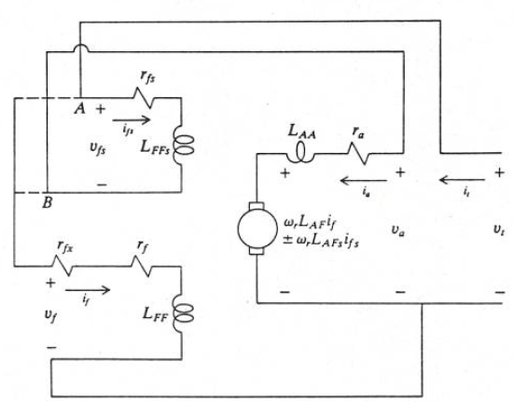

Figure 1: Equivalent circuit of a compound dc machine

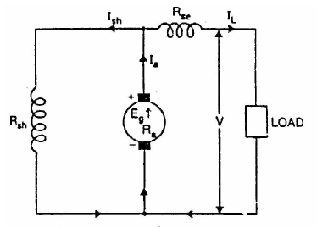

Figure 2: The simplified equivalent circuit for short cumulative generator

The voltage equation of the compound DC machine is: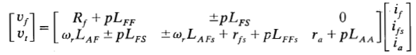

Where

p denotes the derivative with respect to time

LFF the self inductance of the shunt field winding

LAA the self inductance of the armature winding

LFS the mutual inductance between the shunt and the series field

LFFS the self inductance of the series field winding

LAFS the mutual inductance between the series field and armature winding

LAF the mutual inductance between the shunt field and armature winding

We not here that in our case, the generator case and since it is short connection type , in figure 1 the circuit is connected to the point B, and since it is cumulative the + sign in equation is chosen. During generator operation, the armature current ia is negative relative to the positive direction shown in figure 1 as well for the load current ifs. When operating as generator Te , Ia & Ifs are negative.

The important equations resulting from KVL and KCL on circuit depicted in figure 2 are:

-Ea + ra ia + rf if = 0

-Ea + ra ia + rfs ifs + Vt = 0

-rf if + rfs ifs + Vt = 0

Ia = if + ifs

Ea = wr LAF if – wr LAFS ifs

These equations are important especially in the study of steady state behavior as well for deriving the initial condition for the differential equations system.

Describing the DC cumulative generator, the speed is considered as input to the machine, while the output voltage Vt and IL or ifs are the output of the system.

The machine has 4 poles running at 1000rpm, the output voltage due to each the fields separately excited are given respectively by:

a) Ea = 250V, ia = 1A of shunt field.

In this case Ea = *w*r.LAF.if = 250V we have nm = 1000rpm,

Therefore *w*m = 

The relationship between the electrical angle and mechanical angle is given by:

*w*e= where *p*=4 poles

*w*e=

Ea = *w*r.LAF.if = 250V => LAF = 

b) 0.5V / 1A of series field.

Ea = *w*r.LAFS.ifs = 250V => LAFS = 







From the voltage equation we can write:





Where we consider ia and ifs in the opposite direction of figure 1 (generating current).

ia = if + ifs  this allow us to write the differential equations:

dia=(-1/LAA)*(((LFs/LFF)-1)*Vt+(wr*LAF-(rf*LFs/LFF))*If+((LFs*rfs/LFF)-wr*LAFs-rfs)*Ifs+ra*Ia);

dif=(1/LFF)*(Vt+rfs*Ifs-rf*(Ia-Ifs));

dvt=(-LFF/LFs)*(rf-(rf/LFF))*(1/LFF)*(Vt+rfs*Ifs-rf*If);

and  and 

Task #1 : Establishing the voltage Vs. current steady state characteristic of the described DC generator:

The code is the following:

%the voltage vs current & torque vs speed steady state plot characteristic

%of a cumulatively compounded DC generator

%Initializing some values

p=4; %number of poles

n=1000; %generator speed(rpm)

VF=250; %shunt field voltage(V)

IF=1; %shunt field current (A)

VFs=0.5; %series field voltage (V)

IFs=1; %series field current (A)

%Vt=300; %generator rated voltage (V)

%resistances in ohms

rf=130; %shunt field resistance

rfs=0.14; %series field resistance

ra=1.65; %armature resistance

%Calculating the electric speed

We=((2*pi)/60)*(p/2)*n;

%Calculating the mutual inductance between the shunt field and armature winding

LAF=VF/(IF*We);

%Calculating the mutual inductance between armature and series field

LAFs=VFs/(IFs*We);

%Calculation of the induced torque and voltage

wr=104.71;

O=-rf*ra+rfs*wr*LAF-ra*rfs-rf*wr*LAFs-rf*rfs; %parameters for simplification

P=rf-wr*LAF-wr*LAFs; %parameters for simplification

Ia=(0:60);

Vt=(O./P).*(Ia-IF);

wr2=[0:60];

Te2=-wr*LAF*IF*Ia+wr*LAFs*IFs*Ia

Te=2.*(P.^2./O.^2).*Vt.*(-LAF+(rf.*LAF-Vt.*LAFs+rf.*LAFs)./(rf+rfs))-((2.*Vt.*LAF.*P)./(O.*(rf+rfs)));

%Plot the torque-speed characteristic

plot(wr2*60/(2*pi),Te2,'b','linewidth',2),grid

xlabel('Speed,rpm','fontweight','bold')

ylabel('Torque,N.m','fontweight','bold')

title('the torque-speed characteristic')

figure

%Plot the voltage-current characteristic

plot(Ia,Vt,'b','linewidth',2),grid

xlabel('current,A','fontweight','bold')

ylabel('Voltage,V','fontweight','bold')

title('the voltage-current characteristic')

%axis([-30 30 -300 300]);



Figure 3: voltage vs current steady state characteristics



Figure 4: speed vs torque steady state characteristics

As we can conclude in steady state for a varying load, when increasing the current the voltage at the generator terminal decreases linearly. It has the same characteristic in torque vs speed characteristic; when torque increase, the speed decrease and opposes the torque. Talking about the power conservation in the studied system, the mechanical power is almost the electrical power with few losses. So at a specific operating point for current and speed the electric power at this point is almost the same mechanical power for the corresponding torque and speed characteristic.

Suppose that the load on the generator is increased. Then as the load increases and the load current IL increases. Since Ia = If + IL increases, the armature current Ia increases too. At this point two effects occur in the generator:

1. As Ia increases, the Ia ra voltage drop increases as well. This tends to cause a decrease in the terminal voltage Vt = Ea – Ia ra .

2. As Ia increases, the series field magnetomotive force increases too. This increases the total magnetomotive force which increases the flux in the generator. The increased flux in the generator increases Ea, which in turn tends to make Vt rise.

As well a change in the speed of rotation affects the Torque. An increase in w causes Ea = kɸw to increase, increasing the terminal voltage Vt as well decreasing the Torque.

It is mostly the case of undercompound cumulative dc generator when the strength of the series field causes the terminal voltage at full load to be less than at no load.

Since the differential equations describing the system (dia, dif and dVt) derived previously does not change from a task to another, a function code was written and this function was called everytime the ODE23 was used for different tasks and different initial conditions in order to solve for the variables.

The main function code is:

%Main function to be called by ode23 for each task of study in the dynamic performance purpose

function [DCGEN]=dyn2(~,I0,R,L,wr,Ifs)

%Inductances

LAF=L(1);LAFs=L(2);LFF=L(3); LFFs=L(4);LAA=L(5);LFs=L(6);

%Resistances

rf=R(1);rfs=R(2);ra=R(3);

%Initial condition Ia,If & wr

Ia=I0(1);

If=I0(2);

Vt=I0(3);

%equation of derivatives dif, dia & dvt

dia=(-1/LAA)*(((LFs/LFF)-1)*Vt+(wr*LAF-(rf*LFs/LFF))*If+((LFs*rfs/LFF)-wr*LAFs-rfs)*Ifs+ra*Ia);

dif=(1/LFF)*(Vt+rfs*Ifs-rf*(Ia-Ifs));

dvt=(-LFF/LFs)*(rf-(rf/LFF))*(1/LFF)*(Vt+rfs*Ifs-rf*If);

DCGEN=[dia;dif;dvt];

Task #2 initially the generator was running at 300 rpm speed, assuming that the load remain constant so Ifs the speed is dipped to 50% of the original value for 5sec. then increased to 95% of the original value: the dynamic response is to be studied.

In this task we consider the compound DC generator running at constant speed ; it is assumed that the prime mover maintains the speed of the generator constant regardless of the electric load supplied by the generator.

For this task deriving the initial conditions from steady state condition, allow us to reestablish the differential equations and solve them using ode23.

Considering a constant load, since the generator is rated at 30kW and 300V, the rated current is 100A, we choose 50 A as a constant load Ifs in order to accomplish this task.

The code describing this task is the following:

%Dynamic behavior of the DC Generator during a temporary change in speed

clear all

clc

%Initializing some values

p=4; %number of poles

n=300; %generator speed(rpm)

Vf=250; %shunt field voltage(V)

If=1; %shunt field current (A)

Vfs=0.5; %series field voltage (V)

Ifs=1; %series field current (A)

%resistances in ohms

rf=130; %shunt field resistance

rfs=0.14; %series field resistance

ra=1.65; %armature resistance

LFs=0.154; %Mutual Inductance between the shunt and series field (H)

Bm=0.25; %Damping coefficient (N.m.s)%

J=11; %Inertia (Kg.m^2)

tauf=0.36; %Shunt field time constant (sec)

taufs=0.005; %Series field time constant (sec)

taua=0.02; %Armature winding time constant (sec)

%R:Vector for all resistances

R=[rf rfs ra];

%Calculating the electric speed

We=2*(pi/60)*(p/2)*n;

%Calculating the mutual inductance between the shunt field and armature winding (H)

LAF=Vf/(If*We);

%Calculating the mutual inductance between armature and series field (H)

LAFs=Vfs/(Ifs*We);

%Calculating the self inductance of the armature winding (H)

LAA=taua*ra;

%Calculating the self inductance of the shunt field (H)

LFF=tauf*rf;

%Calculating the mutual inductance between the shunt and series field (H)

LFFs=taufs*rfs;

%L:Vector for all self and mutual inductance

L=[LAF LAFs LFF LFFs LAA LFs];

Ifs1=50;

wr=15.705;

wr1=wr;

%Dynamic behavior of the DC Generator for 50% decrease of initial speed

%with constant load

t01=0;

tfinal1=5;

tspan1=[t01,tfinal1];

I01=[48.716 -1.2834 -173.846];

[t1,out1]=ode23(@dyn2,tspan1,I01,[],R,L,wr,Ifs1);

Te1=2*(-LAF.*out1(:,1).*out1(:,2)+LAFs*Ifs1*out1(:,1));

Ifs2=50;

wr=29.8395;

wr2=wr;

%Dynamic behavior of the DC generator for a reestablishment in speed to 95%

t02=tfinal1;

tfinal2=10;

tspan2=[t02,tfinal2];

I02=[42.706 -7.2932 -955.116];

[t2,out2]=ode23(@dyn2,tspan2,I02,[],R,L,wr,Ifs2);

Te2=2*(-LAF.*out2(:,1).*out2(:,2)+LAFs*Ifs2*out2(:,1));

%Plot of armature current ia versus time

subplot(7,1,1),plot(t1,out1(:,1),t2,out2(:,1),'linewidth',2),grid

xlabel('Time,s','fontweight','bold'),ylabel('ia,A','fontweight','bold')

%Plot of shunt field current if versus time

subplot(7,1,2),plot(t1,out1(:,2),t2,out2(:,2),'linewidth',2),grid

xlabel('Time,s','fontweight','bold'),ylabel('If-A','fontweight','bold')

%Plot of series field current ifs versus time

subplot(7,1,3),plot(t1,Ifs1,t2,Ifs2,'linewidth',2),grid

xlabel('Time,s','fontweight','bold'),ylabel('ifs,A','fontweight','bold')

%Plot of output voltage versus time

subplot(7,1,4),plot(t1,out1(:,3),t2,out2(:,3),'linewidth',2),grid

xlabel('Time,s','fontweight','bold'),ylabel('Vt,V','fontweight','bold')

%Plot of electromechanical torque Te versus time

subplot(7,1,5),plot(t1,Te1,t2,Te2,'linewidth',2),grid

xlabel('Time,s','fontweight','bold'),ylabel('Te,N.m','fontweight','bold')

%Plot of speed wr versus time

subplot(7,1,6),plot(t1,wr1*60/(2*pi),t2,wr2*60/(2*pi),'-','linewidth',4),grid

xlabel('Time,s','fontweight','bold'),ylabel('wr,rpm','fontweight','bold')

lambdaA1=LAF*out1(:,2)+LAA*out1(:,1)+LAFs*Ifs1;

lambdaA2=LAF*out2(:,2)+LAA*out2(:,1)+LAFs*Ifs1;

%Plot of the flux linkage of the armature versus time

subplot(7,1,7),plot(t1,lambdaA1,t2,lambdaA2,'linewidth',2),grid

xlabel('Time,s','fontweight','bold'),ylabel('\lambda','fontweight','bold')

The output result are plotted in subplot format for a better comparison between the plot, the blue colored plot correspond to the first 5 seconds when the speed is dropped 50% so to 150 rpm, whereas the green plot is after increasing the speed to 95% of its original value (285 rpm)

The output result is the following, single plots are represented later on for more details.

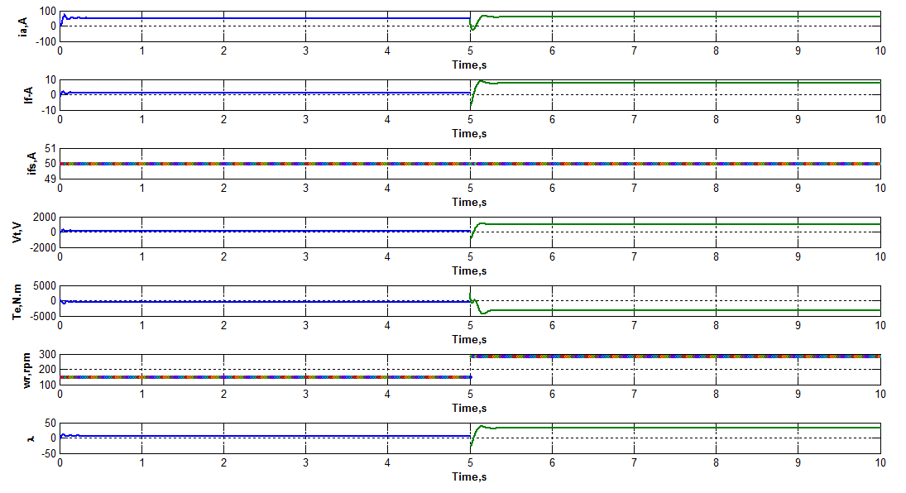

Figure 5: plots results for task 2

For a brief description, as we can for a constant ifs = 50 A and for a time ranging from 0 to 5s wr is 150 rpm, after 5s wr increased spontaneously to 285 rpm which causes the torque to decrease in order to compensate thin increase in speed for a constant load. Ia and If are derived from the differential equations, both increases at 5sec with the increase of speed. Oscillation occurred at transient time. As well for the increase of speed the voltage and the linkage flux have increased.



Figure 6: Plot of shunt armature current if versus time

In the first 5 seconds the generator was operating at a 150 rpm input speed from the prime mover, after 5 sec the speed was reestablished to 95% of its original value which is 285 rpm. This increase in speed at 5 sec so increase in the mechanical input power is translated by an obvious increase in the armature current Ia.



Figure 7: Plot of shunt field current if versus time

An increase in the speed at which the generator runs, caused an increases in the armature current Ia for a constant load current Ifs. Since Ia=If+Ifs, If the field current as well will be affected in the same manner as Ia so an increase in the field current is expected.



Figure 8: Plot of series field current ifs versus time

This plot represent the constant load current Ifs which is 50A during the overall task in order to view the effect of the speed change on the dynamic system behavior.



Figure 9: Plot of output voltage versus time

From the voltage equation, an increase of wr so an increase of Ia at 5seconds will cause an increase as well in Vt. Noting that at every transient, oscillations in the system occur than the system reach steady state.



Figure 10: Plot of electromechanical torque Te versus time

In case of change of the mechanical speed in a generator, the electromechanical torque opposes that speed for a constant load. Thus the power is conservative in the system. That clearly explains the increase of Te negatively at 5 sec.



Figure 11: Plot of speed wr versus time

This plot shows the values of the speed wr, which was150 rpm for the first 5 seconds then 285 rpm. This increases affected the overall system.



Figure 12: Plot of the flux linkage of the armature versus time

The flux linkage is the image of the currents flowing in the armature and field. In this task since field current increased as well for the armature current after increased the speed at t=5 sec, an increase in the flux linkage is normal.

Task #3 initially the generator was running at the speed of task 2 (final speed 285 rpm), assuming that the speed remain constant but load current Ifs was increase by 50% (75 A) from the previous value instantaneously for t = 5s then returned to its value: the dynamic response is to be studied.

In this task we consider the compound DC generator running at constant speed ; it is assumed that the prime mover maintains the speed of the generator constant regardless of the electric load supplied by the generator.

For this task deriving the initial conditions from steady state condition, allow us to reestablish the differential equations and solve them using ode23.

Considering a constant speed all the time, but we increased the load Ifs by 50 % so it is 75A.

The dynamic behavior of the generator is studied after an spontaneous increase in the load while maintaining the speed constant.

The code describing this task is the following:

%Dynamic behavior of the DC generator during a temporary change in the (current) load

clear all

clc

%Initializing some values

p=4; %number of poles

n=300; %generator speed(rpm)

Vf=250; %shunt field voltage(V)

If=1; %shunt field current (A)

Vfs=0.5; %series field voltage (V)

Ifs=1; %series field current (A)

%resistances in ohms

rf=130; %shunt field resistance

rfs=0.14; %series field resistance

ra=1.65; %armature resistance

LFs=0.154; %Mutual Inductance between the shunt and series field (H)

Bm=0.25; %Damping coefficient (N.m.s)

J=11; %Inertia (Kg.m^2)

tauf=0.36; %Shunt field time constant (sec)

taufs=0.005; %Series field time constant (sec)

taua=0.02; %Armature winding time constant (sec)

%Calculating the electric speed

We=2*(pi/60)*(p/2)*n;

%Calculating the mutual inductance between the shunt field and armature winding(H)

LAF=Vf/(If*We);

%Calculating the mutual inductance between armature and series field (H)

LAFs=Vfs/(Ifs*We);

%Calculating the self inductance of the armature winding(H)

LAA=taua*ra;

%Calculating the self inductance of the shunt field(H)

LFF=tauf*rf;

%Calculating the mutual inductance between the shunt and series field(H)

LFFs=taufs*rfs;

%L: Vector for all self and mutual inductances

L=[LAF LAFs LFF LFFs LAA LFs];

%R:Vector for all resistances

R=[rf rfs ra];

%Value of applied voltage (V) and initial calculated current

Ifs1=75;

wr=29.8395;

wr1=wr;

%Dynamic behavior of the DC Generator for 50% increase in load

%with constant speed

t01=0;

tfinal1=5;

tspan1=[t01,tfinal1];

I01=[64.05975 -10.94025 -1432.7325];

[t1,out1]=ode23(@dyn2,tspan1,I01,[],R,L,wr,Ifs1);

Te1=2*(-LAF.*out1(:,1).*out1(:,2)+LAFs*Ifs1*out1(:,1));

Ifs2=50;

wr=29.8395;

wr2=wr;

%Dynamic behavior of the DC generator for a reestablishment in load to initial value

t02=tfinal1;

tfinal2=10;

tspan2=[t02,tfinal2];

I02=[42.706 -7.2932 -955.116];

[t2,out2]=ode23(@dyn2,tspan2,I02,[],R,L,wr,Ifs2);

Te2=2*(-LAF.*out2(:,1).*out2(:,2)+LAFs*Ifs2*out2(:,1));

%Plot of armature current ia versus time

subplot(7,1,1),plot(t1,out1(:,1),t2,out2(:,1),'linewidth',2),grid

xlabel('Time,s','fontweight','bold'),ylabel('ia,A','fontweight','bold')

%Plot of shunt field current if versus time

subplot(7,1,2),plot(t1,out1(:,2),t2,out2(:,2),'linewidth',2),grid

xlabel('Time,s','fontweight','bold'),ylabel('If-A','fontweight','bold')

%Plot of series field current ifs versus time

subplot(7,1,3),plot(t1,Ifs1,t2,Ifs2,'linewidth',1),grid

xlabel('Time,s','fontweight','bold'),ylabel('ifs,A','fontweight','bold')

%Plot of output voltage versus time

subplot(7,1,4),plot(t1,out1(:,3),t2,out2(:,3),'linewidth',2),grid

xlabel('Time,s','fontweight','bold'),ylabel('Vt,V','fontweight','bold')

%Plot of electromechanical torque Te versus time

subplot(7,1,5),plot(t1,Te1,t2,Te2,'linewidth',2),grid

xlabel('Time,s','fontweight','bold'),ylabel('Te,N.m','fontweight','bold')

%Plot of speed wr versus time

subplot(7,1,6),plot(t1,wr1*60/(2*pi),t2,wr2*60/(2*pi),'-','linewidth',1),grid

xlabel('Time,s','fontweight','bold'),ylabel('wr,rpm','fontweight','bold')

lambdaA1=LAF*out1(:,2)+LAA*out1(:,1)+LAFs*Ifs1;

lambdaA2=LAF*out2(:,2)+LAA*out2(:,1)+LAFs*Ifs1;

%Plot of the flux linkage of the armature versus time

subplot(7,1,7),plot(t1,lambdaA1,t2,lambdaA2,'linewidth',2),grid

xlabel('Time,s','fontweight','bold'),ylabel('\lambda','fontweight','bold')

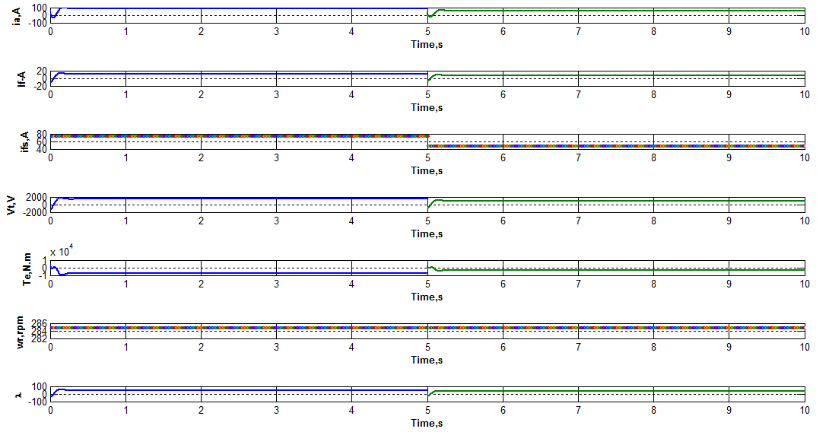

Figure 13: plot results for task 3

During generator mode the field is supplied by the voltage generated by the armature. The shunt winding are wound with a large number of turns of small diameter wire, making the resistance of the field quite large. The series connected field windings are designed as to minimize the voltage drop across it so the winding is wound with few turns of low resistance wire.

In this task the load current was increased 50% so it reaches 75A for the first 5 sec, this increase in Ifs caused an increase in Ia as we can see from the plots which is logical. If is more or less affected. With a constant speed around 285 rpm, an increase in the current load causes a variation in the electromechanical torque Te which increases negatively in order to obey to the conservation of energy rule. Vt is increased as well which is logical and the linkage flux lambda has a values proportional to the currents. After 5 sec the load current was back to its original value 50A so immediately an inverse action is done, Ia has decreased, If slightly affected. Consequently Vt has decreased. For a constant speed Te the electromechanical torque is decreased when Ifs decreased. The flux linkage is related to the currents of armature and field so it is decreases with this decrease in currents.



Figure 14: Plot of shunt armature current if versus time

For the time ranging from 0 to 5s, the current load ifs was increased 50%, than at 5s reset to its original value. For a change in the load current which is the series filed current ifs, ia will be affected since the relation ia= if + ifs. That explains when the load current decreases at 5s Ia decreases.



Figure 15: Plot of shunt field current if versus time

A change in the load current will affect the armature current and the field current by its turn. So that is normal to sketch a slightly decrease at t=5s in the shunt field current.



Figure 16: Plot of series field current ifs versus time

This plot shows the change in the load speed. First from t=0 to 5s in is increased 50% so reaches the value of 75A. For t > 5s the load current is back to its original value.



Figure 17: Plot of output voltage versus time

Form the dynamic equation of the voltage equation Vt , an decrease in the load current Ifs and Ia for a constant speed will cause Vt to decrease consequently.



Figure 18: Plot of electromechanical torque Te versus time

For a decrease in the load, armature current, as well in the output voltage, the output power has totally decreased. For this reason as well the Torque is decreased as well.



Figure 19: Plot of speed wr versus time

This plot is to show that the speed was maintained constant in the overall task.



Figure 20: Plot of the flux linkage of the armature versus time

This plot shows the flux linkage, which is the image of the armature and field currents. And since a decreasing strategy was applied to the currents, the flux linkages decreased as well at t=5s.

Task # 4: in this task a change in the field characteristics are to be studied on the generator dynamic behavior for a constant speed and load:

In this task we will consider no variation in the speed or the load current. Fixing those parameters, a change in the series and shut field characteristics is to be analyzed. Basically independently a change in each field resistors is made while watching its effect on the results. At the end we can decide which field has more effect on the system.

During generator mode the field is supplied by the voltage generated by the armature. The shunt winding are wound with a large number of turns of small diameter wire, making the resistance of the field quite large. The series connected field windings are designed as to minimize the voltage drop across it so the winding is wound with few turns of low resistance wire.

First scenario: changing in series field resistance which should be small:

Normally Rfs = 0.14Ω which is designed to be small in order to minimize the drop voltage across the resistance. We will consider a time ranging from 0 to 2.5 seconds when the series field resistance is the given one 0.14 Ω at 2.5s the field resistance is changed to 10Ω maintaining the same shunt field resistance. This change is simulated and analyzed. The results are shown in figure 21.

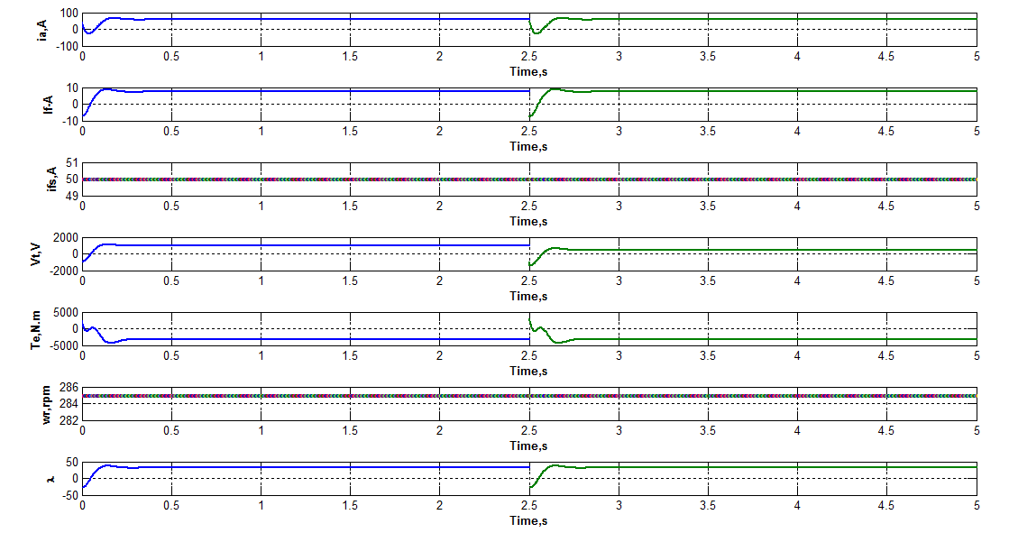

Figure 21: change in series filed resistance rfs=10 Ohms

For this scenario the increasing in the series filed resistance to a larger value, which should be small in order to minimize voltage drop, has caused a large voltage drop therefore a decrease in Vt or load voltage. Other variations are not remarkable.



Figure 22: the voltage drop at the output after increasing the series field rsistance

The voltage drop at the output Vt is remarkable after increasing Rfs the series field resistance.

Second scenario: changing in shunt field resistance which should be quite large initially:

Normally Rf = 130Ω which is designed to be quite large to prevent high starting current and damages. We will consider a time ranging from 0 to 2.5 seconds when the shunt field resistance is the given one 130Ω at 2.5s the field resistance is changed to 110Ω maintaining the same series field resistance. This change is simulated and analyzed. The results are shown in figure 23.



Figure 23: armature current for Rf=110 Ohms.

As we can see the armature current for a low shunt field resistance exceeds the rated value which will damage the machine.

Now let Rf increase to 150 Ω , since it is initially designed to be large we will see the dynamic performance when exceeding the critical value in figure 24.

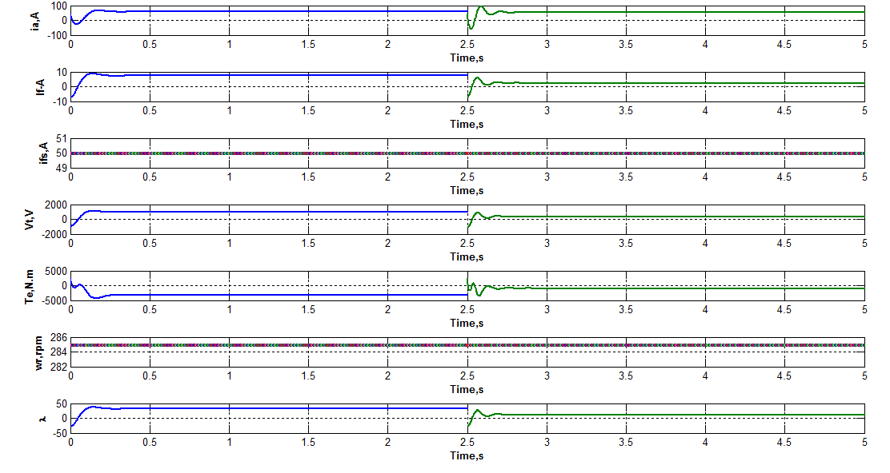

Figure 24: for Rf = 150 Ohms

For an increase in the shunt field resistance a decrease in the shunt field current is obvious, as well a decrease in Vf the shunt field voltage due to a larger drop voltage which by its turn affect the output voltage Vt that decrease. For a constant speed the Torque Te has decreased as well and that make sense since If has decreased.

The main effect on the system is caused when varying the shunt field resistance since the series field resistance is small and can be neglected. At rated speed the voltage across the armature due to residual magnetism is small (build up effect). But this voltage is across the shunt field circuit whose resistance is Rf. Thus, the current which flows in the field circuit If is small when increasing Rf. It is described in the figure below:

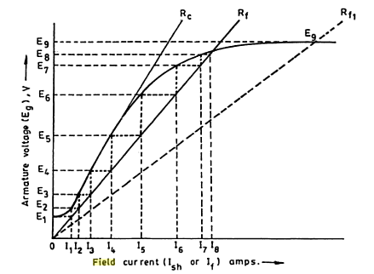

The above description a particular value of field resistance Rf was used for building up of generator excitation. If the field resistance Rf was reduced the build-up process would take place along the field resistance and build-up a somewhat higher value than Ea. The field resistance Rf may be increased until the field circuit reaches a critical field resistance. Field circuit resistance above the critical field resistance will fail to produce build-up as in the second scenario. As well oscillations are more remarkable since the system is no more working at rated values.

**Conclusion:**

In case of a series generator the voltage regulation is very poor but the ability of the series field to produce additional useful magnetization in response to increased load cannot be denied. This useful characteristic of the series field, combined with the relative constant voltage characteristic of the shunt generator, let to the compound generator.

Under-compound generator as in our case has a load characteristic in which the full load voltage is somewhat less than no-load voltage, but whose aiding series field ampere-turns cause its characteristic to have better regulation than a shunt generator.

The compound generator is used more than any other type since its advantages;  
it may be built and adjusted automatically to supply an approximately constant voltage at the point of use.

Compound generators are used to supply power to:

* Railway circuits
* Motor of electrified steam rail-roads
* Industrial motors in many field industry